

Project Management Plan for Internet Banking System

Internet Banking System PMP



October 4, 2022

version 1.2

Prepared by Osama sayed

ITI

ITI SMART VILLAGE

Contents

1. Introduction 2

1.1 Purpose of Project Management Plan 2

1.2 Summary of Project Charter 2

1.3 Assumptions / Constraints 2

1.4 Scope Management 2

1.5 Work Break Down Structure 2

1.6 References 2

1.7 2

2. Change Control Management 2

3. Schedule/ Time management 2

3.1 Milestones 2

3.2 Project Schedule 2

3.3 Dependencies 2

4. Quality Management 2

5. Configuration Management 2

6. Communication Management 2

6.1 Communication Matrix 2

7. Risk 2

7.1 Risk Log 2

8. Issue Management 2

8.1 Issue Log 2

**Revision History**

|  |  |  |  |  |
| --- | --- | --- | --- | --- |
| **Owner Name** | **Date** | **Status** | **Approved by** | **Version** |
| Osama Sayed | 14/4/2022 | Draft | Nada | 1.0 |
| Osama Sayed | 28/4/2022 | Draft | Sara | 1.1 |
| Osama Sayed | 5/5/2022 | Draft | Mariem | 1.2 |

# Introduction

## Purpose of Project Management Plan

The intended audience of the Internet Banking System PMP is all project stakeholders including the project sponsor, senior Leadership and the project team.

## Summary of Project Charter

I. Introduction

Our vision: To make banking services available everywhere for every client.

Our mission: To make it easier for our clients to meet their obligations, transfer money, and complete transactions

II. Business need

Providing easier access to bank system and being available 24/7.

III. Unique Solution

Visiting a bank branch and using regular banking techniques take a long time. As a result, we provide our clients with a unique approach to meet their obligations and access their funds quickly and without excessive fees. We hope to please our customers by providing a user-friendly website.

We aim to make our website reliable and easy to use. It is going to provide clients banking services with a simple click.

IV. Timeline

We plan to provide four milestones for the project and define the project as ready for publishing in 5 weeks of working as it needs approximately 200 hours.

V. Team

Our team consists of 6 members as follow:

1- Saad Hamdy: project manager

2- Aya Shaban: System Analyst

3- Yara Emad: Developer and Tester

4- Mariam Abo Elhamd: Designer & Configuration manager

5- Sara Hussien: Developer and Tester

6- Nada Hussein: Developer and Tester

VI. Conclusion

The project will provide clients easy access to their banking accounts to facilitate banking transactions for them

## Assumptions / Constraints

*Assumptions:*

* We are developing using c#.
* Operating System: Windows, Linux.
* Recommended Conf.: 4Gb RAM or higher, 500mb Disk.

Constraints:

* As this system is an online web-based application so a PC with a good internet connection will be needed for this system.
* Unique user ID.
* Admin features needed.
* System should be user friendly and easy to understand.
* The time constraint for internet banking system is four weeks.
* The security protocol is http.
* There are no constraints or language requirements for tools or databases to be used.

## Scope Management

### 1.4.1 Verification Strategy:

We decided on applying two types of review techniques that are checklist based and exploratory. The reason for using checklist-based technique because it’s systematic and ensures that we don’t miss or skip any main points. We want to check. However, we will also use the exploratory technique because it’s fast and effective under the tight time constraint we have.

### Scope Statement:

Scope Statement.docx

## Work Break Down Structure

WBD.xlsx

## 

## References

None

# Change Control Management

* Change_Management_Plan.doc
* Change-Request.docx

# Schedule/ Time management

## Milestones

The table below lists the milestones for this project, along with their estimated completion timeframe.

| **Milestones** | **Estimated Completion Timeframe** |
| --- | --- |
| * Project plan * SRS (Software requirements Specification) * RTA (Traceability matrixes) * Sample in Question | One Week |
| * Project high level Design * Project Low level design | One Week |
| * Web-based application. * User Manual | One and half Week |
| * Test plan * Quality Reports | One and half Week |

## Project Schedule

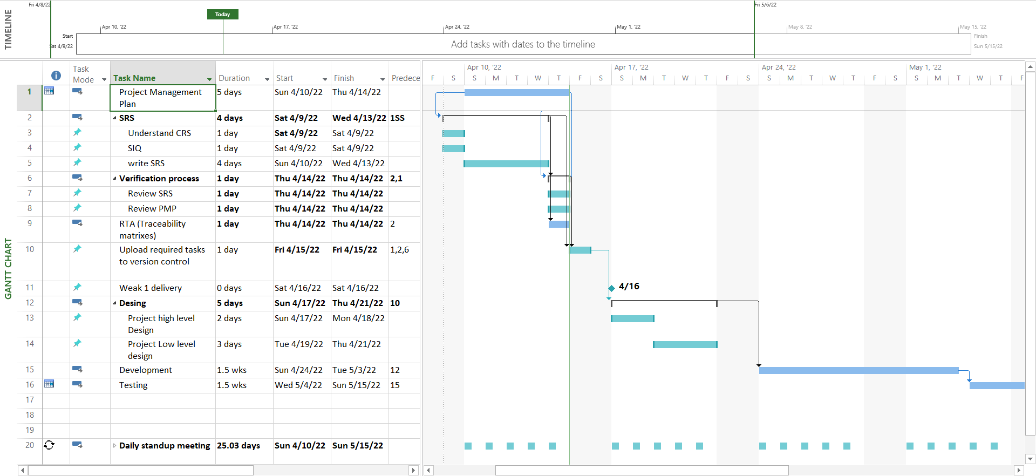

V1.0

Figure 1 [The figure for the project schedule where 1 SS in the precondition column refer to (start to start the process) & other numbers is start to finish process]

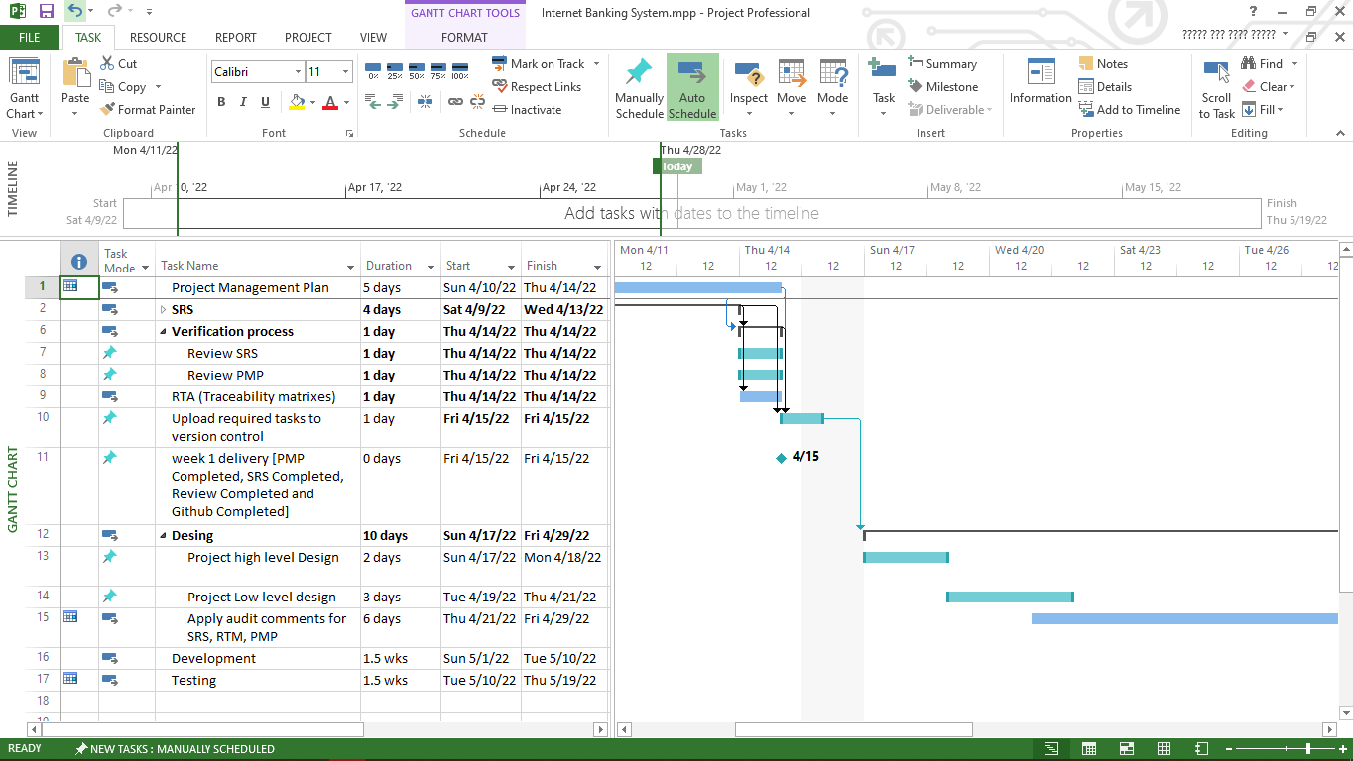

V1.1

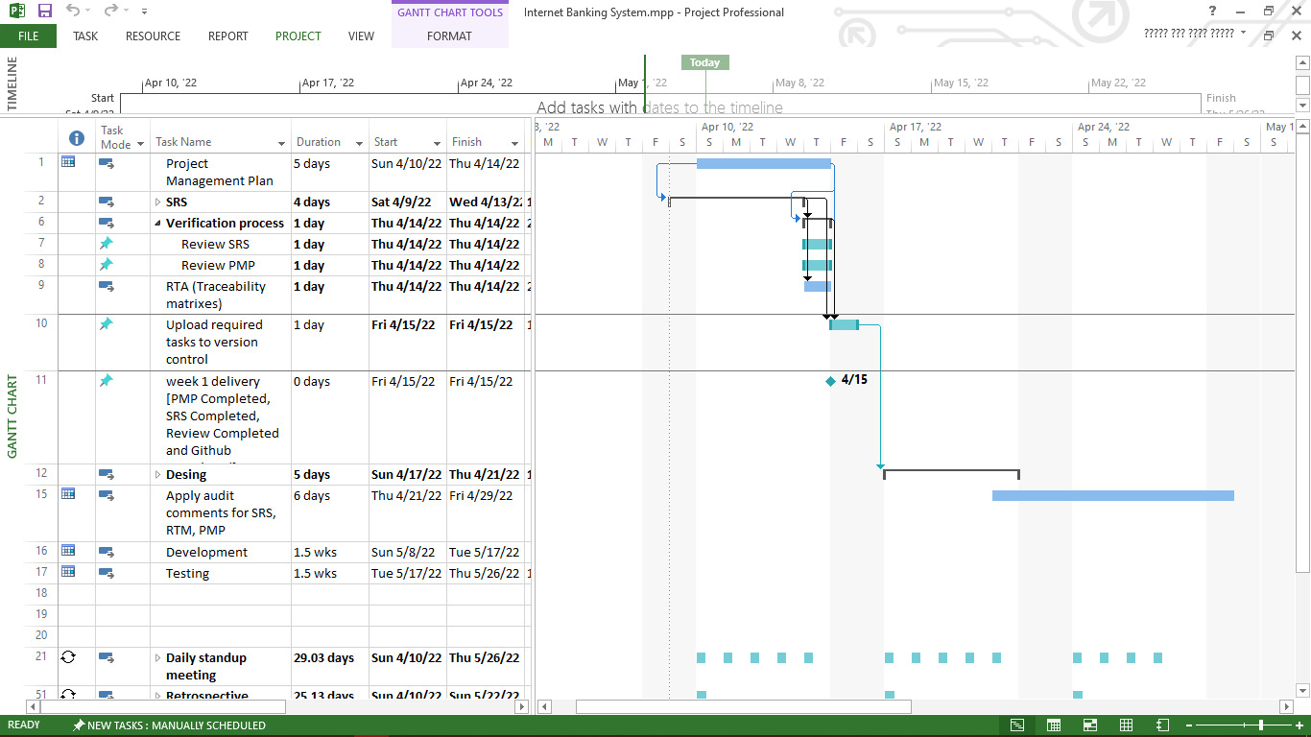

V1.2

Internet Banking System.mpp

## Dependencies

Verification process depends on finishing the PMP & SRS.

RTM depends on finishing SRS.

Push work to base line depends on finishing PMP & SRS.

# Quality Management

Quality_Management_Plan_Template.doc

# Configuration Management

Configuration management plan.docx

# 

# Communication Management

## Communication Matrix

|  |  |  |  |
| --- | --- | --- | --- |
| **Communication Goal** | **Communication Tool** | **Audience** | **Frequency** |
| Team Standup | Online Meeting | Project Team | Daily |
| Project Review | Physical Meeting | Project Team | Weekly |
| Customer Collaboration | Email | Customer – Project Manager | When needed |

# Risk

Risk_Management_Plan.doc

## Risk Log

Risk_Management_Log.xls

# Issue Management

Issue-Management-and-Escalation-Plan.docx

## Issue Log

NA

Appendix A: References

The following table summarizes the documents referenced in this document.

|  |  |  |
| --- | --- | --- |
| **Document Name and Version** | **Description** | **Location** |
| Scope Statement.docx | The in scope and out scope of the project | Definition/Req/Scope Statement.docx |
| WBD.xlsx | High level design of the project | Definition/Design/High Level/WBD.xlsx |
| Change_Management_Plan.doc |  | Monitoring and controlling/ Change_Management_Plan.doc |
| Change-Request.docx |  | Monitoring and controlling/ Change-Request.docx |
| Quality_Management_Plan_Template.doc | Manage the Quality of the Project. | Concept/ Quality_Management_Plan_Template.doc |
| Configuration management plan.docx |  | Definition/ Configuration management plan.docx |
| Risk_Management_Plan.doc |  | Concept/Risk_Management_Plan.doc |
| Risk_Management_Log.xls |  | Concept/Risk_Management_Log.xls |
| Project Charter.docx | Formal short document that describes the project, including what the objectives are, how it will be carried out, and who the stakeholders are. | Definition/Req/Project Charter.docx |
| Issue-Management-and-Escalation-Plan.docx |  | Concept/Issue-Management-and-Escalation-Plan.docx |
| Internet Banking System.mpp | Project schedule | Concept/ Internet Banking System.mpp |

## 